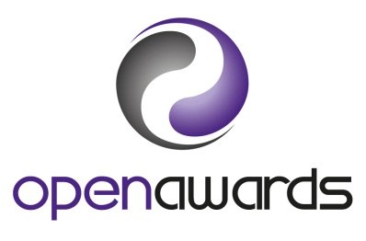
Form LRR

Learner Reissue Request

Please contact Open Awards on 0151 494 2072 before completing this form so we can check to ensure you are registered with Open Awards.

Learner Number:
First Name(s):
Surname:
Date Of Birth:
Telephone Number:

Course Title:
Course Run ID:
Place of Study/Name of Centre:

Proof of identity: DO NOT SEND ORIGINAL DOCUMENTS we only require one copy of any of the documents listed below. If you are requesting an amendment to your personal details (i.e. change of name or date of birth) you must send a copy of one of the documents marked *

Please indicate proof of identity appended to this form:
*Birth Certificate |  | *Deed Poll Certificate |  | Passport
*Naturalisation Certificate |  | NHS Card |  | Identity Card
*Statutory declaration of name change |  | Valid EU Photo ID card |  | Driving Licence

Please tick your preferred method of payment: see overleaf for charges
Cheque/ Postal Order enclosed (made payable to Open Awards). Please send cheques/Postal Order and a copy of you ID (and where applicable your original certificate) to:
Open Awards
17 De Havilland Drive
Estuary Commerce Park
Speke, Liverpool
L24 8RN
Debit Card Payment
Credit Card Payment
To make a card payment please provide your email address below. We will email you a secure link to submit your card details.
Your email address: @
Alternatively you can call 0151 494 2072 to pay.
Internet Banking: You will need an Internet Banking facility to use this payment method.
Internet banking payments to Open Awards:
Sort Code: 01-01-97
Account Number: 21078025

Please quote your name in the ‘Reference Box’.

REPLACEMENT CERTIFICATE

I wish to apply for a replacement certificate
Reason for Replacement

Postal Address
Please provide a postal address for your certificate

Depending on payment method (see front page) please email the form and scanned copy of your ID to customerservices@openawards.org.uk

NB: If you are requesting an amendment to your certificate you must return the original certificate with the form, payment and a copy of one of the following: birth certificate, naturalisation certificate, statutory declaration of name change or deed poll certificate to:
Open Awards
17 De Havilland Drive
Estuary Commerce Park
Speke, Liverpool
L24 8RN
Tel: 0151 494 2072.

LEARNER ACHIEVEMENT REPORT

I wish to apply for a Learner Achievement Report
The report is a PDF document and will be emailed to you, please provide your email address below:
@

Depending on payment method (see front page) please email the form and scanned copy of your ID to customerservices@openawards.org.uk

